# Commonwealth of Pennsylvania

## Milk Marketing Board

2301 North Cameron Street

Harrisburg, PA 17110-9408

717-787-4194

FAX -717-705-2712

WEB SITE: http://www.mmb.pa.gov E-mail: RA-pmmb@pa.gov

April 17, 2017

Dear Licensed Cooperative:

The Milk Producers’ Security Act requires dealers to provide a bond to secure payment for the milk they buy from producers. A cooperative is not required to post a bond for its own members’ milk.

However, a cooperative is considered a dealer with respect to milk it buys from other cooperatives. For that milk, the cooperative must either post a bond or obtain a waiver from the selling cooperative. The selling cooperative must notify its members about the waiver by mail.

A waiver form is enclosed for each cooperative that you buy milk from, according to our records. **You must have the selling cooperative(s) complete the waiver(s).**  If you buy milk from any other cooperatives, you must also obtain waivers from them. The form is available on our website – www.mmb.state.pa.us. You must obtain these waivers even if you have obtained them previously, because we are updating our records.

The waiver(s) from the cooperative(s) you buy milk from and the enclosed Cooperative Waiver Questionnaire must be returned to us with your Application for Milk Dealer’s License **by June 15, 2017**.

If you have any questions, please contact Fatima Roberge at 717.836.3114, or contact me at 717.787.194.

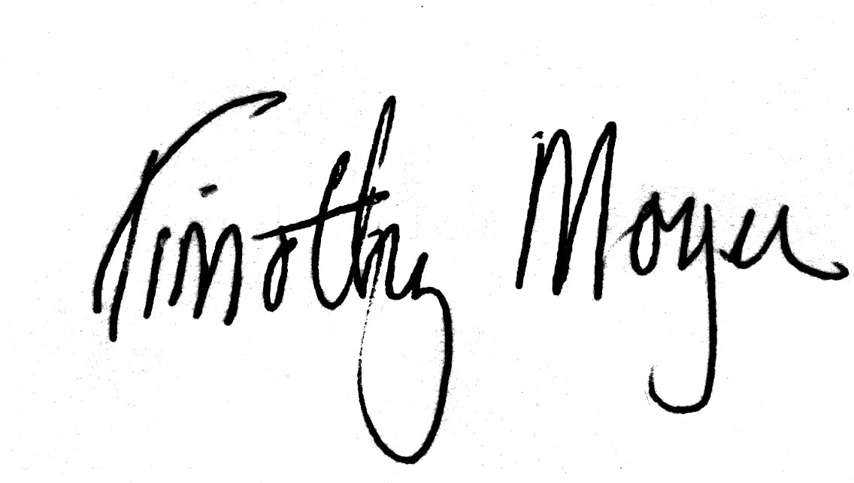Very truly yours,

Timothy Moyer

Secretary

Enclosures