PMMB-001
(Rev. 4/18)

Commonwealth of Pennsylvania
Milk Marketing Board
2301 North Cameron Street – Room # 110
Harrisburg, PA 17110

Website: www.mmb.pa.gov

Phone: 717.787.4194

Fax: 717.783.6492
Fax: 717.705.2712

2018-2019
NEW APPLICATION

DEALER/SUBDEALER

for Milk License

Commonwealth of Pennsylvania
PMMB-001
(Rev. 4/18)

Milk Marketing board
dealer/subdealer license - new application

Please read this license application carefully AND complete applicable information.

Please refer to page 5 for explanation of Dealer/Subdealer

Enter license year JULY 1, 2018 through JUNE 30, 2019

license request: dealer — (DEALERS MUST COMPLETE PAGES 2, 3, 4, 6, AND 8 WHERE APPLICABLE)
SUBDEALER — (SUBDEALERS MUST COMPLETE PAGES 2, 3, 4, 7AND 8 WHERE APPLICABLE)

1. entity type: individual organization

list the name exactly as it should appear on license:

Name on License: _________________________________________________________________________________________________________

if name on license is fictitious name (d/b/a or trade name), list individual or organization name:

______________________________________________________________________________________________________________________________

*organization Type: partnership LLC cooperative corporation other __________________________________________

(state incorporated/organized) ___________________ (date incorporated/organized)

Note: for partnerships, corporations, cooperatives or limited liability companies, please attach a list of partners, officers and directors, or members as applicable with position held and address. Attach a separate sheet of owners/stockholders that own 20% or greater share of the business and indicate the number of shares for each stockholder.

2. licensee address: (this is the address that will appear on printed license and where all correspondence will be mailed).

(street) (city) (state) (county) (zip)
3. (FOR OUT-OF-STATE APPLICANTS ONLY) list address in PA where records are kept. if no address is listed, applicant consents to provide records at the licensee address above, the board office, or other location designated by the board.

(contact person) (street Address) (city) (state) (zip) (phone)

4. designate an agent within Pennsylvania upon whom service of process may be made by the board: if no agent is listed, applicant consents to service by mail at the licensee address above or as otherwise permitted by Pennsylvania law.

(contact Person) (street Address) (city) (state) (zip) (phone)

5. place conducting business in Pennsylvania (if different than 2 or 3): ___________________________________________________

_________________________________________________________________________________________________________________

6. Office Phone: __________________________________________________________________________________________________
number - include Area Code (extension) (contact Person)

7. fax: ___________________________________________________________________________________
number (include Area code)

8. email address: ___________________________________________________________________________

web address: _____________________________________________________________________________________

9. has applicant or any partner, officer, or management employee been convicted of a felony, or forfeited bond or collateral in connection with a criminal charge, within the last five years? Yes No if yes, explain ___________________________________________________

10. is applicant a subsidiary of, affiliated with, or associated either directly or indirectly with any other individual, corporation or company (this includes entities not involved in any way with milk)? Yes No if yes, explain on a separate sheet.

11. a. will any store or other business that you own, control, or have a financial or other interest in, buy packaged milk or cream products? Yes No

b. will any store or other business that owns, controls or have a financial or other interest in you, buy packaged milk or cream products? Yes No

if yes to 11a or 11b, attach a separate sheet providing the information indicated below for each such store or other business:

1.) name and address 2.) type of business 3.) business relationship

12. do you have adequate technical personnel and adequate technical and physical facilities to properly conduct the business of receiving and handling milk? Yes No If no, explain

Type of Milk business licensee operates
(MUST BE COMPLETED)

For DEALERS Only: Please Complete the Following sections

13. Check all that apply:

purchase milk directly from individual producers (farmers). (Attach list of name and address of each producer [farmer])

purchase milk from cooperatives. attach list of name and address of each cooperative you buy from OR sell to& specify accordingly.

purchase bulk milk/cream from other Dealers.

purchase from:

purchase packaged milk/cream products for resale: whole milk low fat skim flavored fluid creams

purchase from

process and sell milk/cream products produced on own farm only list locations where milk is sold:

_______________________________________________________________________________________________________________________________________________________________________________________________________________________________________________________________________________________________________________________

14. Check all that apply:

process and package milk/cream products whole milk low fat skim flavored fluid creams

use milk/cream to manufacture products ice cream Butter cheese milk powder other _____________________

sell packaged milk/cream products: whole milk low fat skim flavored fluid creams other ____________

check business category of sales: restaurants Schools Stores Subdealers Other _______________________

See Map - page 5: indicate area(s) in which you will be selling packaged milk/cream products:

Area 1 Area 2 Area 3 Area 4 Area 5 Area 6

sell bulk milk/cream
List purchaser (dealer name(s) ___________________________________________________________________________________________

________________________________________________________________________________________________________________________

Cooperative Processing Manufacturing Marketing (if applicable)

- Attach a separate sheet, even if previously provided, showing sources of milk that the cooperative purchases, handles, or receives within Pennsylvania.

- List name, address, and telephone number for each source of milk, and briefly describe the agreement for purchasing, receiving, or handling the milk.
(Note: Purchases from independent producers or other cooperatives must be secured by a bond.)

- A cooperative selling to or purchasing from another cooperative may waive the bond requirement by providing the Board with an executed bond waiver for those sales.

- If a waiver has been executed, attach a copy of letter notifying membership of waiver of bond protection on milk sold to or purchased from other cooperatives, and a list of the members to whom the letter was sent.

- If a waiver has been executed, attach a copy of the waiver of bond protection on milk purchased from or sold to other cooperatives.

- Number of Pennsylvania members _________ number of Pennsylvania non-member producers ____________
SUBDEALERS ONLY: PLEASE COMPLETE THE FOLLOWING SECTION

15. check all that apply:

purchase packaged milk/cream products for resale: whole milk low fat skim flavored fluid creams

purchase from:

sell packaged milk/cream products: whole milk low fat skim flavored fluid creams

check business category of sales: Restaurants schools stores other

see map page 5 indicate area(s) of sales:
Area 1 Area 2 Area 3 Area 4 Area 5 Area 6

sell packaged milk/cream products to consumers in a store that you wholly own or operate
check all that apply: whole milk low fat skim flavored creams

sell packaged milk/cream products in vending manchines
whole milk low fat skim flavored creams other _____________________________

do you own the vending machines? Yes No

DEALERS/SUBDEALERS: COMPLETE THIS SECTION

contact information: please list the name and phone number of the person responsible for the items listed below.
write “n/a” if not applicable. The annual license renewal and financial statement forms will be mailed to the attention of the person named in A.

a. Renewal Application: _____________________________________________________________________________
(name) (phone Number – include area code)

B. Dealer’s Monthly Report: _____________________________________________________________________________
(name) (phone Number – include Area Code)

C. Dealer’s Financial Statement: ___________________________________________________________________________
(name) (phone number – include Area Code)

NOTICES: the milk marketing law requires mailing Official General Orders to licensees. if you prefer them emailed to you please provide your email below. if you want them mailed to you, and are not currently receiving them, by mail, please provide the address and contact person in the space below.

a. Official General Orders / Hearing Notices/ Bulletins: _______________________________________________________
(EMAIL)

b. Monthly Producer Prices (if you wish to receive them): ______________________________________________________
(EMAIL)

C. Monthly WHOLESALE/RETAIL Prices (if you wish to receive them): _____________________________________________
(EMAIL)

MAP

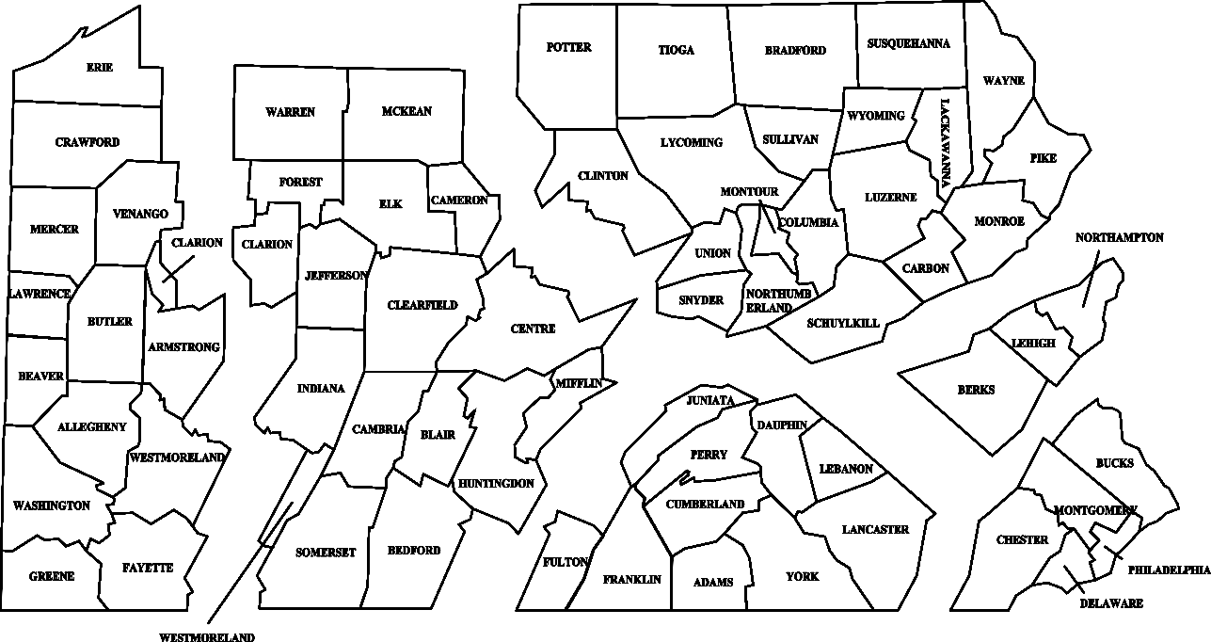

AREA 3

AREA
2

AREA 5 AREA 6 AREA 4 AREA 1

DEALER

A Dealer purchases, receives, or handles milk within Pennsylvania, for processing or manufacture and further sale, within or out of Pennsylvania. A producer who only delivers milk to a dealer is not considered a dealer. A cooperative that distributes milk in Pennsylvania to stores, consumers, or other milk dealers, or acts as an agent for its members is considered a dealer as to that part of its business.

SUBDEALER

A Subdealer handles milk within Pennsylvania and delivers the milk to consumers, schools, institutions, or stores in the same containers in which the subdealer purchased it. Stores are not subdealers.

These are general descriptions and do not cover every situation. Please contact us if you are not sure whether to apply to be a dealer or a subdealer.

DEALER FINANCIAL SCHEDULE
License Fees, Financial Statement, and Bond Computation

License Fees:

New licensee applicants or applicants not licensed for a full calendar year are required to attach the annual fixed fee as described in A. below. Review the hundredweight fee described in B which will be due on a monthly basis upon being licensed.

A. Annual Fixed Fee

1. New licensees licensed as of July 1 shall pay an annual fixed fee of $100.00

2. Licensees not engaged in the milk business on July 1, shall pay a proportionate fixed annual fee as follows:

  - For a license issued on or after October 1 but before January 1 of the succeeding year, the fee is $75.00.

  - For a license issued on or after January 1 but before April 1, the fee is $50.00.

  - For a license issued on or after April 1 but before July 1, the fee is $25.00.

B. Hundredweight Fee

in addition to the annual fixed fee, a milk dealer who did not hold a license for the complete preceding calendar year shall pay on a monthly basis the following hundredweight fees. The monthly payment shall accompany the PMMB-62, Milk Dealer’s Monthly Report.

- for packaged milk/cream products received, produced, or brought into this Commonwealth during the previous month: fee is $.045 per hundredweight.

- For milk on which the Board has not fixed a price, received, produced, or brought into this Commonwealth during the previous month: fee is $.0057 per hundredweight.

These monthly payments shall continue through June of the year following a full calendar year of monthly payments. The monthly reports and fees for the full calendar year will be used as the basis for the calculation of fees and bonding requirements for the succeeding license year.

financial statement:

Attached is an annual report or a comprehensive financial statement.

computation of dealer Bond:

as a new applicant, you must complete this section. enter dollar values in the following table by estimating the anticipated purchases for each month, starting with the month you anticipate starting business.

(a) Record the anticipated dollar value of purchases from Pennsylvania producers (farmers) or cooperatives; and/or

(b) Record the anticipated dollar value of purchases from producers (farmers) or cooperatives located outside
Pennsylvania.

 | (a) | (b) | Total Value  (A+B) |  | (a) | (b) | Total Value  (A+B)
January |  |  |  | July
February |  |  |  | August
March |  |  |  | September
April |  |  |  | October
May |  |  |  | November
June |  |  |  | December

To calculate the amount of bond to be posted, use the following:

From the Total Value column on the above chart, identify the two (2) consecutive month period with the highest aggregate amount (i.e. add Months 1 and 2, then Months 2 and 3, etc.)

1. Months of ____________________and____________________ Total for both months: $

DEDUCTIONS: value of milk purchased or received from producers and cooperatives outside of Pennsylvania for which a bond has been
filed with the state where the milk is purchased. (must attach copies of bonds filed in other states.)

2. Less any deductions $

3. Net amount: line 1 minus line 2 above $

4. Net amount: line 3 divided by number of days in months in line 1 times 40 $

5. A bond equal to the amount on line 4 must be provided

6. Attached: □ corporate surety bond in the amount of OR

□ collateral bond in the amount of $
SUB-DEALER FINANCIAL SCHEDULE
License Fees, Evidence of Financial Responsibility, and Bond Computation

License Fees:

A. Annual Fixed Fee

New licensees shall pay an annual fixed fee of $50.00 OR a proportionate fixed fee as follows:

- $37.50 for a license issued on or after October 1 but before January 1 of the succeeding year.

- $25.00 for a license issued on or after January 1 but before April 1 of the same year.

- $12.50 for a license issued on or after April 1 but before July 1 of the same year.

PLUS

B. quarts- equivalent Fee

In addition to the annual fixed fee, a Sub-Dealer shall pay, on an annual basis, a fee on milk on which the Board sets prices. The quart-equivalent fee shall be assessed in accordance with the following schedule.

Average Quarts Purchased Per Month | Annual Fee
1 - 29,999 | $50.00
30,000 - 59,999 | $100.00
60,000 - 119,999 | $150.00
120,000 - 149,999 | $200.00
150,000 - 199,999 | $250.00
200,000 - 299,999 | $300.00
300,000 - 399,999 | $400.00
400,000 - 599,999 | $500.00
600,000 - 799,999 | $800.00
800,000 - 999,999 | $1200.00
1,000,000 & Over | $1400.00

C. Calculate your License Fee

1. Annual Fixed Fee $
2. Annual quart -equivalent fee $

TOTAL LICENSE FEE DUE $

evidence of financial responsibility:

The following is being filed with this application (check only one):

Corporate Surety
Collateral Bond
(collateral must be attached to Bond form. please see reverse side of Bond form for types of acceptable collateral).
COD (collect on Delivery) Letter

computation of sub-dealer Bond:

As a new applicant, you must complete this section if a bond is needed.

Enter dollar values in the following table by estimating the anticipated purchases of “price-controlled packaged products”
for each month, starting with the month you anticipate starting business. Price-controlled packaged products are Class I and II milk products which are listed on the PMMB monthly price sheets and purchased in Pennsylvania.

 | Value |  | Value
January |  | July
February |  | August
March |  | September
April |  | October
May |  | November
June |  | December

The amount of the bond to be posted will be the highest value for the month identified from the value column in the above chart.

1. Month of__________________________________ Total for month identified $

2. Attached hereto is a: Corporate Surety Bond in the amount of $
Collateral Bond in the amount of $
I CERTIFY that all of the statements made by me are true, complete, and correct, to the best of my knowledge and belief, and are made in good faith. i am aware that all statements made by me on this document are subject to investigation prior to issuance of any license. i also understand that i may be refused a license and that my license may be suspended or revoked if i make any statement upon which the license was issued, which statement is found to have been false or misleading in any material particular.

A duly authorized individual must execute this application. if the applicant is a corporation, the signature of an officer of the corporation is required. if the applicant is a partnership, all partners must sign. if the applicant is a sole proprietorship, the sole proprietor must sign. if an individual, the individual must sign.

Signature Date

Title
(Please type or print name signed above)

Signature Date

Title
(Please type or print name signed above)

I have enclosed the following:

license application (Signed)
license fee of $__________ (check made payable to:
“commonwealth of Pennsylvania”) **
bond form
dealer collateral (collateral must be attached to bond form)
dealer Surety
sub-dealer collateral (collateral must be attached to bond form)
sub-dealer Surety
COD (collect on delivery) letter - where applicable
waivers (where applicable)
financial statement (dealers only)
addendum (food banks only)

failure to provide all requested information including license fees and bond (if applicable)
will result in application being returned, and no license issued.

this application must be completed and filed prior to engaging in business. renewal applications are required annually thereafter,
on, or before JUNE 15 for the license year starting July 1.

CONTACT INFORMATION:

Fatima Roberge or Tim Moyer
717.836.3114 717.836.3110

** there is a $20.00 service charge for any returned checks, and you may be subject to interest and penalties
,

