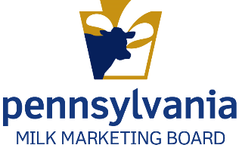
Commonwealth of Pennsylvania
Milk Marketing Board
Dealer License – New Application

Please read the application carefully and answer all applicable items.

Enter License Year July 1,_______ through June 30,_______

Applications are due 30 days from date of receipt.

- List the Name exactly as it should appear on the license ________________________________

______________________________________________________________________________

If name on license is fictitious name (d/b/a or trade name), list individual or organization name:

______________________________________________________________________________

- Entity Type: Partnership LLC Corporation Other: _______________________

State Incorporated/Organized:_____________ Date Incorporated/Organized:___________________

- Licensee Address: (Address which will appear on printed license and where all correspondence will be mailed)

(Street) (City) (State) (County) (Zip Code)

(Primary Contact Person) (Phone – include area code) (Email address)

(Secondary Contact Person) (Phone – include area code) (Email address)

______________________________ ___________________________________
(Office fax number – include area code) (Web address)

- For Out-of-State Applicants Only: List PA address where records are kept. If no address is listed, applicant consents to provide records at the Board office or other location designated by the Board.

___________________________________________________________________________________
(Contact Person) (Phone – include area code) (E-mail address)

(Street) (City) (State) (County) (Zip Code)

______________________________ ___________________________________
(Office fax number – include area code) (Web address)

- For Out-of-State Applicants Only: Designate an agent within Pennsylvania upon whom service of process may be made by the Board. If no agent is listed, applicant consents to service by mail at the Licensee Address above or otherwise permitted by Pennsylvania law.

__________________________________________________________________________________
(Contact Person) (Phone – include area code) (E-mail)

(Street) (City) (State) (County) (Zip Code)

______________________________ ___________________________________
(Office fax number – include area code) (Web address)

- For All Applicants: Place conducting business in Pennsylvania (if different than #3 or #4):

___________________________________________________________________________________
(Contact Person) (Phone – include area code) (E-mail)

(Street) (City) (State) (County) (Zip Code)

______________________________ ___________________________________
(Office fax number – include area code) (Web address)

- Has applicant or any partner, officer or management employee been convicted of a felony, or forfeited bond or collateral in connection with a criminal charge within the last five years?

Yes No If, Yes, explain: ___________________________________________________

______________________________________________________________________________

- Is applicant a subsidiary of, affiliated with, or controlling owner in other individual, corporation or company (includes entities not involved in any way with milk?

Yes No If, Yes, explain: ___________________________________________________

______________________________________________________________________________

- Will any store or other business that you own, control or have a financial or other interest in, buy packaged milk or cream products. Yes No Does not apply

- Will any store or other business that owns, controls or has a financial or other interest in you/your business, buy packaged milk or cream products? Yea No Does not apply

If you answered, “Yes,” to #8 or #9, attach a separate sheet to provide the information below for each store or other business:

- Name and Address 2. Type of Business 3. Business Relationship

- Do you have adequate technical personnel and adequate technical and physical facilities to properly conduct the business of receiving and handling milk? Yes No If “No, explain.

_________________________________________________________________________________

Details of Business Operations

- Check all that apply. Your purchases.

Purchase milk directly from individual producers (farmers). Attach list of name and address of each producer/farmer.
Purchase milk from cooperative(s). Attach list of name and address of each cooperative you buy from OR sell to and specify which (buy or sell)
Purchase bulk milk/cream from other dealers.

Purchase from: ________________________________________________________________

Purchase packaged milk/cream for resale: Whole milk 2% or 1% Skim Flavored
Fluid creams

Purchase from: ________________________________________________________________

Process and sell milk/cream that is produced on own farm only.

Location of sales: On farm sales Off-farm sales locations (Specify) ___________

_____________________________________________________________________________

- Check all that apply. Your processing, manufacturing and sales.

Process and package milk/cream products: Whole Milk 2% or 1% Skim Flavored
Fluid creams

Use milk/cream to manufacture products: Ice cream Butter Cheese Milk Powder
Other

Sell packaged milk/cream products: Whole milk 2% or 1% Skim Flavored Other

Check business(es) sold to: Restaurants Schools Stores Subdealers Other

Sell bulk milk/cream (List purchaser(s): _________________________________________________

_____________________________________________________________________________________

- Refer to Pennsylvania map on following page. In which PA Milk Marketing Areas will you be selling packaged milk/cream products? Check all that apply.

Area 1 Area 2 Area 3 Area 4 Area 5 Area 6

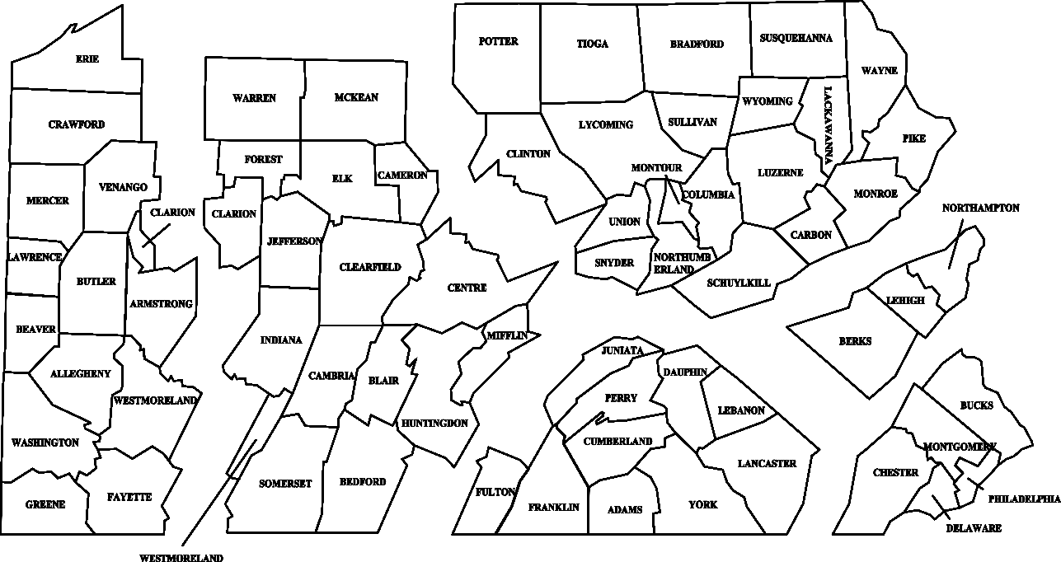
Area 3

________________________________________________________________________________________________________________________

Area 2

Area 5
Area 6
Area 4
Area 1

Persons Responsible and Contact Information

- Please list the names of person(s) responsible for the items below. Write N/A if not applicable. Provide address, email, phone and fax number if not provided on pages 1 and 2. The Annual License Renewal and Financial Statement forms will be sent to the person identified as contact for Renewal Application.

Preferred Contact by: Mail Email Phone

Renewal Application: __________________________________________________________________

Dealer’s Monthly Report: ______________________________________________________________

Dealer’s Financial Statement: ___________________________________________________________

- The Milk Marketing Law requires mailing Official General Orders to licensees. Please list the names of person(s) responsible for receiving the items below. Provide address, email, phone and fax number if not provided on pages 1 and 2 or in Item 15.

Preferred Contact by: Mail Email

Official General Orders/Hearing Notices/Bulletins: __________________________________________

Monthly Producer Prices (if you wish to receive): ___________________________________________

Monthly Wholesale/Retail Prices (if you wish to receive): ____________________________________

Dealer Financial Schedule
License Fees, Financial Statement and Bond Computation

License Fees: New applicants are required to attach the annual fixed fee as described in (A) below. Review the hundredweight fee described in (B), which will be due on a monthly basis once licensed.

- Annual Fixed Fee for new licenses is based on date of application:
- For license applications submitted between July 1 and before January 1 - $100.00
- For license applications submitted on or after January 1 - $50.00

Note: Prorated annual fixed fee for new licenses accounts for new license year beginning July 1 of each succeeding year.

- Hundredweight Fee: In addition to annual fixed license fee, a milk dealer who did not hold a license for the complete calendar year shall pay, monthly, the following hundredweight fees:
- For packaged milk/cream products received, produced or brought into this commonwealth during the previous month – Fee is $0.060 per hundredweight.
- For milk on which the Board has not fixed a price, received, produced or brought into this commonwealth during the previous month – Fee is $0.0064 per hundredweight.

These monthly payments shall continue through June of the year following a full calendar year of monthly payments. The monthly reports and fees for the full calendar year will be used as the basis for the calculation of fees and bonding requirements for the succeeding license year.

Financial Statement:

An annual report or a comprehensive financial statement is attached.

Computation of Dealer Bond: As a new applicant, you must complete this section. Enter dollar values in the following table by estimating the anticipated purchases for each month, starting with the month you anticipate starting business, or the current month if you are already in business.

- Record the anticipated dollar value of purchases from Pennsylvania producers (farmers) or cooperatives; and/or
- Record the anticipated dollar value of purchases from producers (farmers) or cooperatives located outside Pennsylvania.

 | (A) | (B) | Total  (A+B) |  | (A) | (B) | Total  (A+B)
January |  |  |  | July
February |  |  |  | August
March |  |  |  | September
April |  |  |  | October
May |  |  |  | November
June |  |  |  | December

Deductions: Value of milk purchased or received from producers and cooperatives outside of Pennsylvania for which a bond has been filed with the state where the milk is purchased. (must attach copies of bonds filed in other states.)

- Bond Calculation:
- From the table above, identify the two consecutive months that have the highest aggregate months. (Add Jan + Feb, Feb + Mar, Mar + Apr, etc.).

- Two highest consecutive months are __________ and __________

- Total dollar amount for two highest consecutive months (from above)______________________

- Amount of deductions: ________________________

- Line 1 – Line 2 ________________________

- Number of days in two highest consecutive months: ________________________

- Divide amount in Line 3 by days in Line 4 (=amount per day) ________________________
- Multiply dollar amount from Line 5 x 40 ________________________
Net Amount
- A bond equal to the amount on Line 6 must be provided.

Attached: Corporate surety bond in the amount of ________________________

OR

Attached: Collateral bond in the amount of ________________________

I CERTIFY that all of the statements made by me are true, complete, and correct to the best of my knowledge and belief and are made in good faith. I am aware that all statements made by me on this document are subject to investigation prior to issuance of any license. I also understand that I may be refused a license and that my license may be suspended or revoked if I make any statement upon which the license was issued, which is found to have been false or misleading in any material particular.
A duly authorized individual must execute this application. If the applicant is a corporation, the signature of an officer of the corporation is required. If the applicant is a partnership, all partners must sign. If the applicant is a sole proprietorship, the sole proprietor must sign. If an individual, the individual must sign.

____________________________________________________________________________________
(Typed or Printed Name) (Title) (Date)

______________________________________________
(Signature)

_________________________________________________________________________________
(Typed or Printed Name) (Title) (Date)

______________________________________________
(Signature)

Required Attachments Checklist

Signed application (Electronic signatures are acceptable if applications is submitted via email.).

Note: Application will not be processed until check(s) and bond are received in PMMB office.

Check for license fee in the amount of $____________________ made out to Commonwealth of Pennsylvania. (Note: A $20 fee is assessed for any returned check.)

Partnerships, corporations, and LLCs must attach a list of partners, officers and directors, or members (as applicable) with positions held and addresses.

Separate sheet of owners/stockholders that own 20% or greater share in the business. Indicate the number of shares for each stockholder.

List of all producers that milk is purchased from

List of all cooperatives milk is purchased from

Bond form

Dealer collateral (must be attached to bond form)

Dealer surety

Financial statement

Need Assistance or Information?

Jim Petrascu, Staff Attorney: (717) 787-4194 or by email at jpetrascu@pa.gov

To Submit Your Application

Mail to: Email to:

PA Milk Marketing Board Fatima Roberge
2301 N. Cameron St. froberge@pa.gov
Harrisburg, PA 17110

