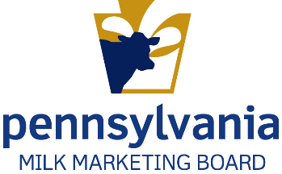
Commonwealth of Pennsylvania
Milk Marketing Board
SUBDEALER License – New Application

Please read the application carefully and answer all applicable items.

A Subdealer handles milk within Pennsylvania and delivers the milk to consumers, schools, institutions, or stores in the same containers in which the subdealer purchased it. Stores are not subdealers.

Enter License Year July 1, _______ through June 30, ________

Applications are due 30 days from date of receipt.

- Applicant Name as it should appear on license: _______________________________________

______________________________________________________________________________

- Entity Type: Partnership LLC Corporation Other: _________________________

State Incorporated/Organized:_______________ Date Incorporated/Organized:____________________

- Licensee Address: (Address which will appear on printed license and where all correspondence will be mailed)

(Street) (City) (State) (County) (Zip Code)

(Primary Contact Person) (Phone – include area code) (Email address)

(Secondary Contact Person) (Phone – include area code) (Email address)

______________________________ ___________________________________
(Office fax number – include area code) (Web address)

- For Out-of-State Applicants Only: List PA address where records are kept. If no address is listed, applicant consents to provide records at the Licensee Address above, the Board office, or other location designated by the Board.

___________________________________________________________________________________
(Contact Person) (Phone – include area code) (E-mail address)

(Street) (City) (State) (County) (Zip Code)

______________________________ ___________________________________
(Office fax number – include area code) (Web address)

- For Out-of-State Applicants Only: Designate an agent within Pennsylvania upon whom service of process may be made by the Board. If no agent is listed, applicant consents to service by mail at the Licensee Address above or otherwise permitted by Pennsylvania law.
____________________________________________________________________________________
(Contact Person) (Phone – include area code) (E-mail)

(Street) (City) (State) (County) (Zip Code)

______________________________ ___________________________________
(Office fax number – include area code) (Web address)

- For All Applicants: Place conducting business in Pennsylvania (if different than #3 or #4):

___________________________________________________________________________________
(Contact Person) (Phone – include area code) (E-mail)

(Street) (City) (State) (County) (Zip Code)

______________________________ ___________________________________
(Office fax number – include area code) (Web address)

- Has applicant or any partner, officer or management employee been convicted of a felony, or forfeited bond or collateral in connection with a criminal charge within the last five years?

Yes No If, Yes, explain: __________________________________________________

- Is applicant a subsidiary of, affiliated with, or associated either directly or indirectly with any other individual, corporation or company (includes entities not involved in any way with milk?

Yes No If, Yes, explain: __________________________________________________

______________________________________________________________________________

- Will any store or other business that you own, control or have a financial or other interest in, buy packaged milk or cream products. Yes No Does not apply

- Will any store or other business than owns, controls or has a financial or other interest in you/your business, buy packaged milk or cream products? Yes No Does not apply

If you answered, “Yes,” to #8 or #9, attach a separate sheet to provide the information below for each store or other business:

- Name and Address 2. Type of Business 3. Business Relationship

- Do you have adequate technical personnel and adequate technical and physical facilities to properly conduct the business of receiving and handling milk? Yes No If “No, explain.

_________________________________________________________________________________
Details of Business Operations

- Check All That Apply:

Purchase packaged milk/cream products for resale. Whole Milk 2% and/or 1%
Skim Flavored Fluid cream

Purchase from: _______________________________________________________________

Check business category of sales: Restaurants Schools Stores
Other _________________________________________________________________

Sell packaged milk/cream products to consumers in a store that you wholly own or operate?
Whole milk 2% and/or 1% Skim Flavored Creams

Sell packaged milk/cream products in vending machines. Whole milk 2% and/or 1%
Skim Flavored Other ______________________________________________

Do you own the vending machines? Yes No

Use the map below to answer Item 13 on the following page:
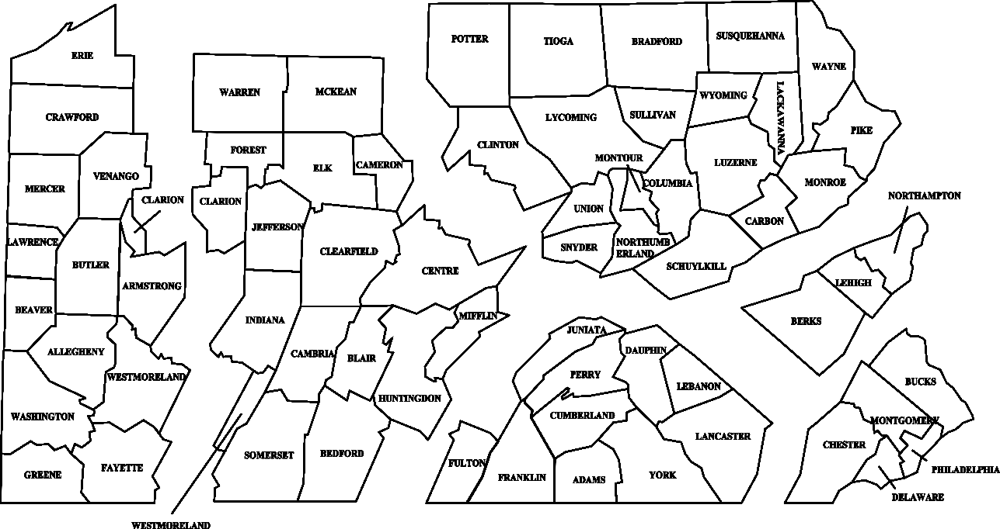
Area 3
Area 5
Area 6
Area 4
Area 1
Area 2
_______________________________________________________________________________________________________________

- Check all that apply. In which of the PA Milk Marketing Areas will you be selling packaged milk/cream products?

Area 1 Area 2 Area 3 Area 4 Area 6

Persons Responsible and Contact Information

- Please list the names of person(s) responsible for the items below. Write N/A if not applicable. Provide address, email, phone and fax number if not provided on pages 1 and 2. The Annual License Renewal and Financial Statement forms will be sent to the person identified as contact for Renewal Application.

Preferred Contact by: Mail Email Fax

Renewal Application: __________________________________________________________________

Subdealer’s Monthly Report: ___________________________________________________________

Subdealer’s Financial Statement: ________________________________________________________

- The Milk Marketing Law requires mailing Official General Orders to licensees. Please list the names of person(s) responsible for receiving the items below. Provide address, email, phone and fax number if not provided on pages 1 and 2 or in Item 14.

Preferred Contact by: Mail Email

Official General Orders/Hearing Notices/Bulletins: __________________________________________

Monthly Producer Prices (if you wish to receive): ___________________________________________

Monthly Wholesale/Retail Prices (if you wish to receive): ____________________________________

Subdealer Financial Schedule
License Fees, Evidence of Financial Responsibility and Bond Calculation

License Fees:

- New licensees pay an Annual Fixed Fee of $50.00 (due with application).

- Quarts Equivalent Fee: In addition to the Annual Fixed Fee, a subdealer shall pay, on an annual basis, a fee on milk and products on which the Board sets prices. The quart-equivalent fee shall be assessed in accordance with the following schedule:

Average Quarts Sold Per Month | Annual Fee
1 – 29,999 | $ 62.50
30,000 – 59,999 | $ 125.00
60,000 – 119,999 | $ 187.50
120,000 – 149,999 | $ 200.00
150,000 – 199,999 | $ 312.50
200,000 – 299,999 | $ 375.00
300,000 – 399,999 | $ 500.00
400,000 – 599,999 | $ 625.00
600,000 – 799,999 | $ 1,000.00
800,000 – 999,999 | $ 1,500.00
1,000,000 and over | $ 1,750.00

- Calculate your license fee:

- Annual Fixed Fee $50.00

- Annual Quart-Equivalent Fee _________________

- Line 1 + Line 2 _________________ = Total License Fee Due
with Application

Evidence of Financial Responsibility:

The following is being filed with this application: (Check ONLY ONE.)

Corporate Surety

Collateral Bond (Collateral MUST BE attached to bond form. Please see reverse side of bond form for types of acceptable collateral.

COD (Collect on Delivery letter)

Computation of Subdealer Bond: As a new applicant you MUST complete this section if a bond is required.

- Enter dollar values in the following table by estimating the anticipated purchases of “price-controlled packaged products” for each month, starting with the month you anticipate you will be starting your business.

Price-controlled packaged products are Class I and Class II milk products that are listed on the PMMB monthly price sheets and sold in Pennsylvania.

 | Value |  | Value
January |  | July
February |  | August
March |  | September
April |  | October
May |  | November
June |  | December

The amount of the bond to be posted is the highest value identified from the two value columns in the table above.

- Month of ______________ Value for month identified $___________________

- Attached herein is a

Corporate Surety Bond in the amount of $______________________

Collateral Bond in the amount of $______________________

I CERTIFY that all of the statements made by me are true, complete, and correct to the best of my knowledge and belief and are made in good faith. I am aware that all statements made by me on this document are subject to investigation prior to issuance of any license. I also understand that I may be refused a license and that my license may be suspended or revoked if I make any statement upon which the license was issued, which is found to have been false or misleading in any material particular.

A duly authorized individual must execute this application. If the applicant is a corporation, the signature of an officer of the corporation is required. If the applicant is a partnership, all partners
must sign. If the applicant is a sole proprietorship, the sole proprietor must sign. If an individual, the individual must sign.

____________________________________________________________________________________
(Typed or Printed Name) (Title) (Date)

______________________________________________
(Signature)

_________________________________________________________________________________
(Typed or Printed Name) (Title) (Date)

______________________________________________
(Signature)

Required Attachments Checklist

Signed application (Electronic signatures are acceptable if applications is submitted via email.).

Note: Application will not be processed until check(s) are received in PMMB office.

Check for license fee in the amount of $____________________ made out to Commonwealth of Pennsylvania. (Note: A $20 fee is assessed for any returned check.)

Partnerships, corporations, cooperatives and LLCs must attach a list of partners, officers and directors, or members (as applicable) with positions held and addresses.

Separate sheet of owners/stockholders that own 20% or greater share in the business. Indicate the number of shares for each stockholder.

Bond form

Subdealer collateral (must be attached to bond form), if applicable.

Subdealer surety, if applicable

COD letter, if applicable

Financial statement

To Submit

By Mail: By Email:

PA Milk Marketing Board Fatima Robertge
2301 N. Cameron St. froberge@pa.gov
Harrisburg, PA 17110

Note: Applications submitted by email will not be processed until fee and bond are received in our office.

Need Assistance or Information?

Jim Petrascu, Staff Attorney: (717) 787-4194 or by email at jpetrascu@pa.gov.

